Hardware Schematic
Environment Monitoring Device · CSPC-ICTU Server Infrastructure Monitoring System · October 2026

1. Overview
The environment monitoring device is an ESP32 microcontroller mounted on an ESP32 shield (expansion) board inside a DIY electronic project box in the server room. It measures temperature, humidity and smoke, raises local alarms, controls the air-conditioning units by infrared, and keeps readings on a microSD card while the backend cannot be reached.
The schematic on the next page shows every module and the ESP32 pin it uses. Section 3 lists the same connections as a table, for wiring or checking the box.

2. Components
Component | Qty | Role
ESP32 development board | 1 | Reads the sensors, drives the outputs, sends data over Wi-Fi
ESP32 shield (expansion board) | 1 | Holds the ESP32; takes power in by USB-C and gives labelled 5V, V (3.3 V) and GND headers
DHT22 sensor | 1 | Temperature and humidity
MQ-2 gas/smoke sensor | 4 | Smoke and gas at four separate points in the room
10 kΩ / 20 kΩ resistors | 1 pair per MQ-2 | Voltage divider: scales the 5 V MQ-2 output to 3.3 V
KY-005 IR transmitter | 4 | Sends the captured remote-control codes to the AC units
Passive piezo buzzer | 1 | Audible alarm, different tones per alert level
WS2812B addressable LED strip | 16 LEDs | Colour status: green normal, yellow warning, red critical
DS3231 RTC module + coin cell | 1 | Keeps the time through power cuts, for buffered readings
microSD card module (SPI) | 1 | Offline buffer while the backend is unreachable
Momentary push button | 1 | Hold 3 s to enter Wi-Fi / backend setup mode
Mini UPS (5 V 2 A) | 1 | Supplies the 5 V rail and keeps the device running during a power interruption
30 cm gooseneck holders | 4 | Aim the four IR transmitters

Figure 1. Wiring schematic (3D view)
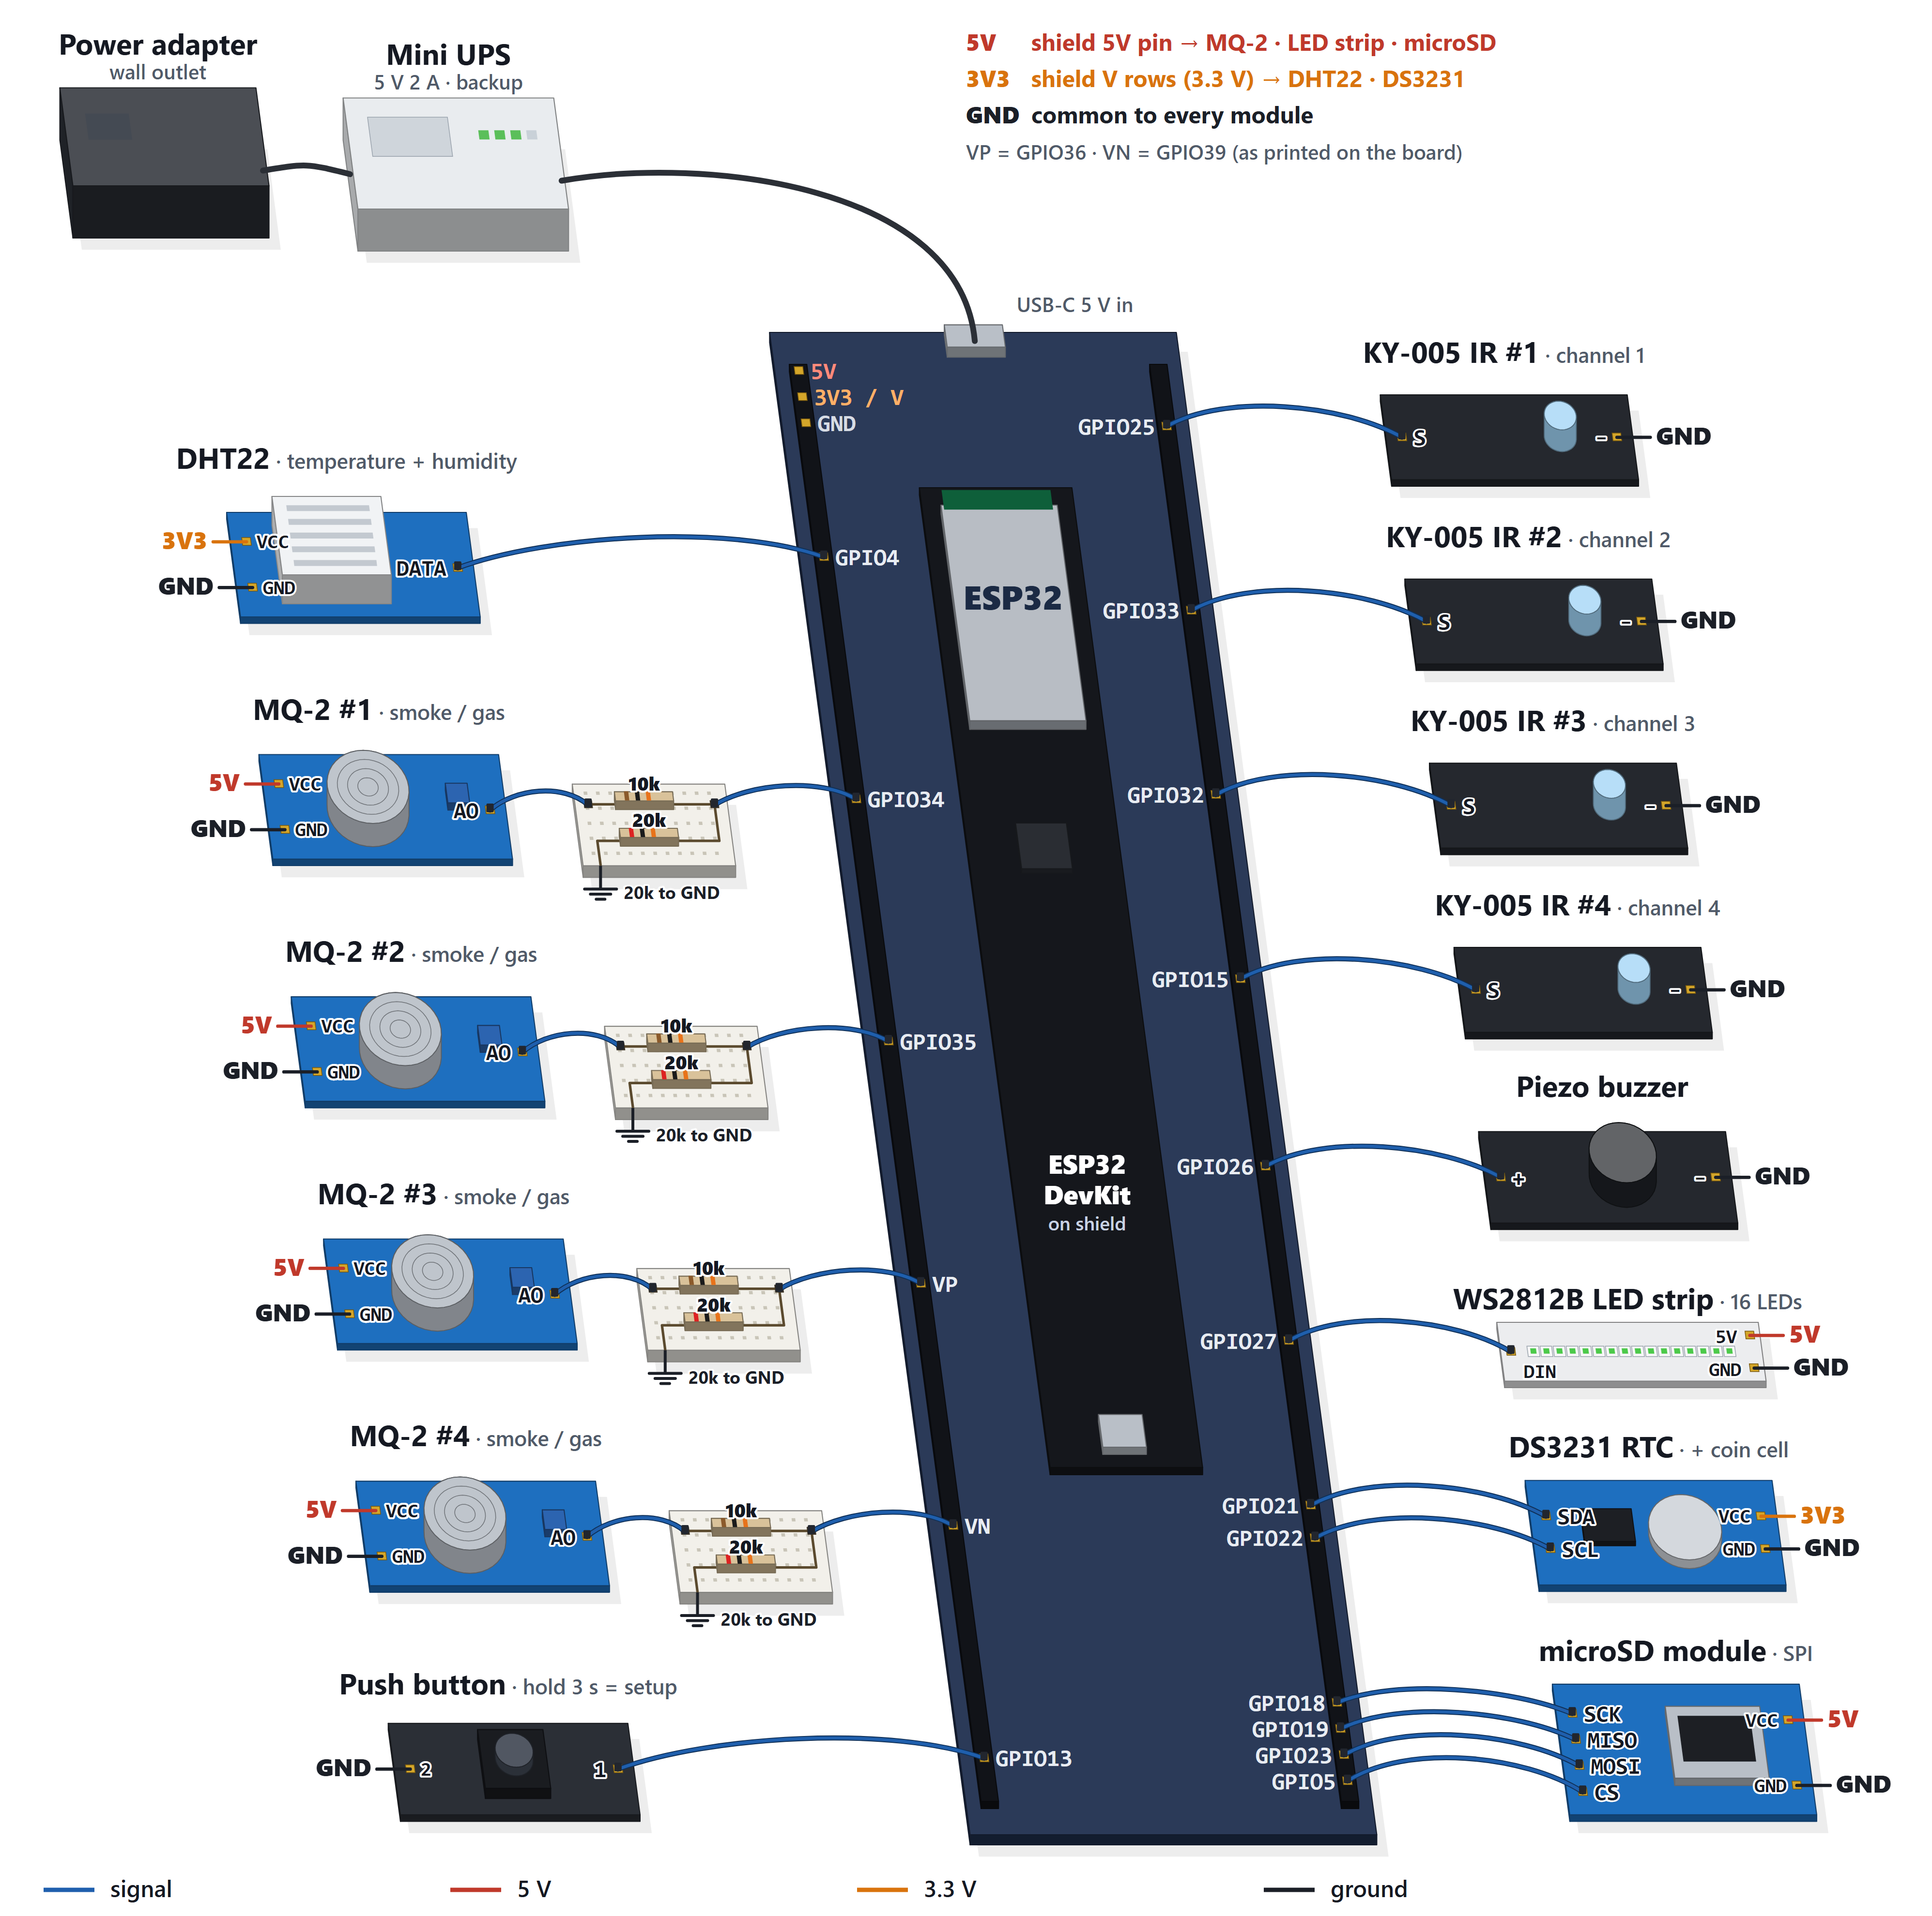
Rail labels (5V / 3V3 / GND) connect to the matching row on the ESP32 shield.

3. Pin connections
Component | Module pin | Connects to | Notes
DHT22 | VCC / GND | V row (3.3 V) / GND
DHT22 | DATA | GPIO4
MQ-2 #1 | VCC / GND | Shield 5V pin / GND | The heater needs 5 V, not the V row
MQ-2 #1 | AO | GPIO34 | AO → 10 kΩ → GPIO34; 20 kΩ from GPIO34 to GND
MQ-2 #2 | VCC / GND | Shield 5V pin / GND
MQ-2 #2 | AO | GPIO35 | Through its own divider
MQ-2 #3 | VCC / GND | Shield 5V pin / GND
MQ-2 #3 | AO | VP (GPIO36) | Through its own divider; enable channel 3 in the dashboard
MQ-2 #4 | VCC / GND | Shield 5V pin / GND
MQ-2 #4 | AO | VN (GPIO39) | Through its own divider; enable channel 4 in the dashboard
KY-005 IR #1 | S / − | GPIO25 / GND | IR channel 1
KY-005 IR #2 | S / − | GPIO33 / GND | IR channel 2
KY-005 IR #3 | S / − | GPIO32 / GND | IR channel 3; register its AC unit in the dashboard
KY-005 IR #4 | S / − | GPIO15 / GND | IR channel 4; register its AC unit in the dashboard
Piezo buzzer | + / − | GPIO26 / GND
WS2812B LED strip | DIN | GPIO27 | 3.3 V data works directly
WS2812B LED strip | 5V / GND | Shield 5V pin / GND
DS3231 RTC | SDA / SCL | GPIO21 / GPIO22 | I2C
DS3231 RTC | VCC / GND | V row (3.3 V) / GND | Coin cell fitted on the module
microSD module | SCK / MISO / MOSI / CS | GPIO18 / 19 / 23 / 5 | SPI
microSD module | VCC / GND | Shield 5V pin / GND
Push button | two legs | GPIO13 / GND | Uses the ESP32's internal pull-up; no resistor
ESP32 | — | Shield socket | Powered by the shield; nothing on VIN

4. Power
Mains power goes from the power adapter into the Mini UPS (5 V 2 A), whose 5 V output plugs into the USB-C input on the ESP32 shield. The shield's on-board regulator powers the ESP32 and the shield's header rows. The Mini UPS battery keeps the device running during a power interruption.
- 5 V: the shield's dedicated 5V pin. Powers the MQ-2 sensors, the WS2812B strip and the microSD module.
- 3.3 V: the shield's V rows, with the 5V/3.3V jumper set to 3.3 V. Powers the DHT22 and the DS3231.
- GND is common to every module.

5. Wiring notes
- Keep the shield jumper on 3.3 V. It sets every V pin beside a signal pin. On 5 V, the DHT22 would put 5 V on GPIO4, which the ESP32 does not tolerate. Modules that need 5 V take it from the shield's 5V pin instead.
- MQ-2 voltage divider. The MQ-2 outputs up to 5 V, but an ESP32 input accepts only 3.3 V. AO → 10 kΩ → ESP32 pin, with 20 kΩ from that pin to GND, gives 5 V × 20/30 = 3.3 V. Each MQ-2 needs its own pair.
- VP and VN are input-only. On the board they are printed VP and VN, not GPIO36 and GPIO39. They are fine for MQ-2 #3 and #4 but cannot drive an IR transmitter, which is why IR #3 and #4 are on GPIO32 and GPIO15.
- The MQ-2 sensors use ADC1 pins (32–39) because the ADC2 pins stop working while Wi-Fi is on.
- A new MQ-2 is not read until it is enabled on the Environment page. An unconnected analog pin reads noise that would look like smoke.
- After rewiring or moving an MQ-2, recalibrate it in clean air (Recalibrate on the Environment page).
- DS3231 coin cell. Common DS3231 boards charge the cell, which suits a rechargeable LIR2032. With a non-rechargeable CR2032, remove the board's charging diode or resistor first. Without a working cell, readings buffered during an outage cannot be dated, and are not saved.
- Setup mode. Hold the push button for 3 seconds at any time to restart into Wi-Fi / backend setup. The ESP32's BOOT button does the same just after power-up.

